To-Do List Application Project

Erin Whitmore
Software Engineering, University of Minnesota Crookston
SE 2300: Software Construction
Dr. Silvia Preston
January 20, 2026

To-Do List Application Project
Many people struggle with keeping track of tasks in their daily lives, especially in the modern day. That’s why to-do list applications have become more and more popular. This document will serve to outline the major steps that will be taken to complete the project from start to finish. These steps include project selection, requirements gathering, architecture design, detailed planning, proposed implementation, testing and validation, and documentation.
Project Selection
My software project is a to-do list application that tracks various tasks listed by the user. It will be using a command line interface and built with Python. The application will primarily consist of 4 different options when running—adding a new task, updating a task, deleting an existing task, listing all current tasks, and exiting the program.
Requirements Gathering
Functional Requirements:

- The system shall allow users to create as many tasks as desired
- The system shall display the list of all tasks when prompted by the user
- The system shall update a task when prompted by the user
- The system shall allow users to delete any and all tasks

Non-functional Requirements:

- The system shall load the task list within 2 seconds
- Task creation, updating and deletion shall be completed in under 1 second
- The system shall be intuitive without the need for user training
- Common actions (add, update, delete) shall require no more than 2-3 user interactions

Architecture Design

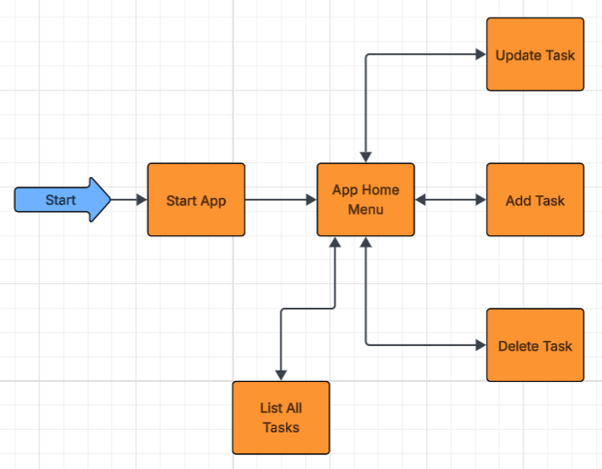
User Flow Diagram 1
In the above user flow diagram, users will start the application and then be directed to the home menu where the app will prompt the user to select from a list of options. From there, users may choose to update tasks, add tasks, delete tasks, or list all current tasks. Upon completion of any of the options, the user will automatically be directed back to the application home menu, where they will again see the list of options they may choose from.

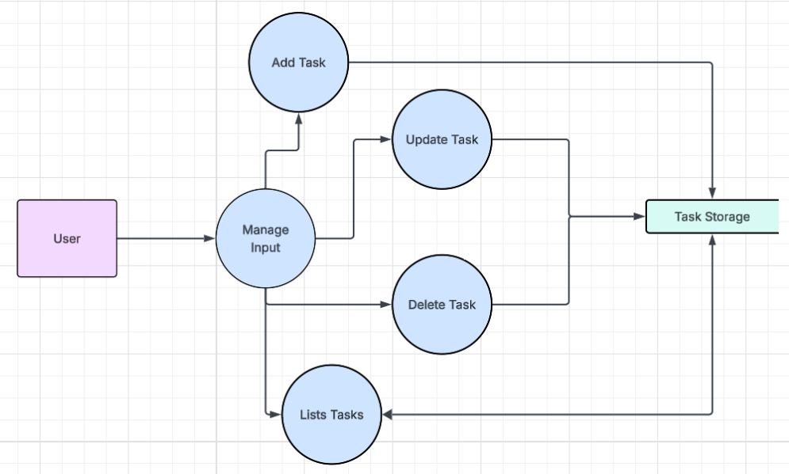
Data Flow Diagram 1
In the above data flow diagram, the external entity consists of the user. Processes include managing input, adding tasks, updating tasks, deleting tasks, and listing all tasks. The Task Storage represents the data store.
The user may choose to manage input in a variety of ways. Once a task has been added, the user may choose to update the task, delete the task, or have the program list the task(s). Each of these processes must have access to the Task Storage to manage insertion, deletion, updating, and outputting of the tasks. When choosing to List Tasks, the program accesses the Task Storage to retrieve and print tasks to the console.

Detailed Planning

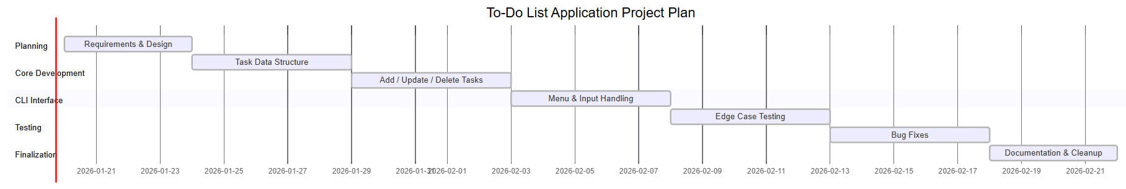
Gantt Diagram 1
The above Gantt Diagram includes the milestones necessary for completion of the project.
- Milestone 1: Requirements and Design- includes requirements gathering and design of the project. Core features such as tasks are outlined and functionality is planned before any coding begins.
- Milestone 2: Task Data Structure- the internal data structure used to store tasks is designed and implemented. This includes deciding how tasks are represented in memory.
- Milestone 3: Add/Update/Delete Tasks- involves implementing the core functionality that allows users to manage tasks. Users will be able to add new tasks, modify existing ones, and delete tasks from the list.
- Milestone 4: Menu & Input Handling- the command-line menu system is created to allow users to interact with the application. User input is captured and routed to the appropriate task operations until the user exits.
- Milestone 5: Edge Case Testing- focuses on testing the application under unusual or incorrect conditions, such as an empty task list or invalid user input. Ensure the program behaves predictable and does not crash in these scenarios.
- Milestone 6: Bug Fixes- any issues discovered during testing are addressed. Code is refined to fix errors and ensure all features work as intended.
- Milestone 7: Documentation & Cleanup- involves cleaning up the codebase and preparing documentation. This includes adding comments as needed and organizing the project so it is clear, readable, and ready for future modifications.
The Gantt timeline goes until the end of February for ample development time and planning, though project completion is expected to be sooner than that.
Proposed Implementation
The proposed implementation of this project will aim to follow the design and timeline outlined in the project plan, with development proceeding through defined goals. The application will be built as a command-line to-do list program that allows users to add, update, delete, and list tasks through a simple menu. Functionality will be focused on first, followed by input handling, testing, and refinement. This allows for validation of functionality and reduces risk by identifying issues.
Python is the chosen programming language for this project due to its readability, simplicity, and the developer’s own familiarity with the language. Python’s clear syntax helps keep the focus on programming logic rather than complex language features. Functions will be used to separate task management and user interaction, and comments will be added where necessary to ensure clarity. This will ensure the code is easy to read and extend in the future.
Testing and Validation
The following test cases are only a few that will be performed. Testing for this project will be done alongside development to ensure that each feature meets the requirements. Individuals tasks such as adding, updating, deleting, and listing tasks will be tested as they are implemented to confirm they behave as expected. Additionally, edge cases will be done to validate the program’s integrity. This includes testing conditions such as an empty task list, invalid task selections, and unexpected user input.
Test Case 1: Add a New To-Do list item
Objective: Verify that a user can successfully add a new to-do item to the list.
- Start the program
- Select the “Add Item” option
- Enter a valid title for the to-do item
- Press Enter
Expected Result: The new to-do item is visible and has been added to the list when the user opts to view the list.
Test Case 2: Delete a To-Do list item
Objective: Verify that a user can successfully delete a to-do item from the list.
- Start the program
- Select the “Delete Item” option
- Enter the number representing the item you wish to delete
- Press Enter
Expected Result: The to-do item has been deleted and is not visible when the user opts to view the list.
Test Case 3: Editing an Existing To-Do item
Objective: Verify that a user can successfully update a to-do item from the list.
- Start the program
- Select the “Update Item” option
- Enter the number representing the item you wish to update
- Press Enter
Expected Result: The to-do item has been updated and reflects the changes when the user opts to view the list.
Documentation
User Manual:
- Start the To-Do list application by clicking the triangle shaped “Run” button.
- The application will present a list of tasks for you to choose from. These include:
  - 1) Adding a list item.
  - 2) Updating a list item.
  - 3) Removing a list item.
  - 4) Viewing the entire list of items.
- Type and enter the number corresponding to the option you wish to pick. If you are using the application for the first time, you should add a list to the item. When the application directs you back to the main menu, you should choose the option to view the entire list so that you can verify the item has been added.
- Each list item will have a number corresponding to that unique list item. For example:
  - 1) Do the dishes
  - 2) Pickup drycleaning
etc…
- When you wish to delete a list item, choose the option corresponding to that option (3) and the application will ask you to choose the number corresponding to the item you wish to delete. Once you have removed an item from the list, choose the option to view the entire list (4) when the application directs you back to the main menu to ensure it has been removed.
- If you’d like to update a list item, choose the option corresponding to that option (2) and the and the application will ask you to choose the number corresponding to the item you wish to update. Once you have updated a list item, choose the option to view the entire list (4) when the application directs you back to the main menu to ensure it has been updated.
Github Repository: https://github.com/ewhitmo/SE-2300-Project

